Level 1 - Simple (7 Queries)

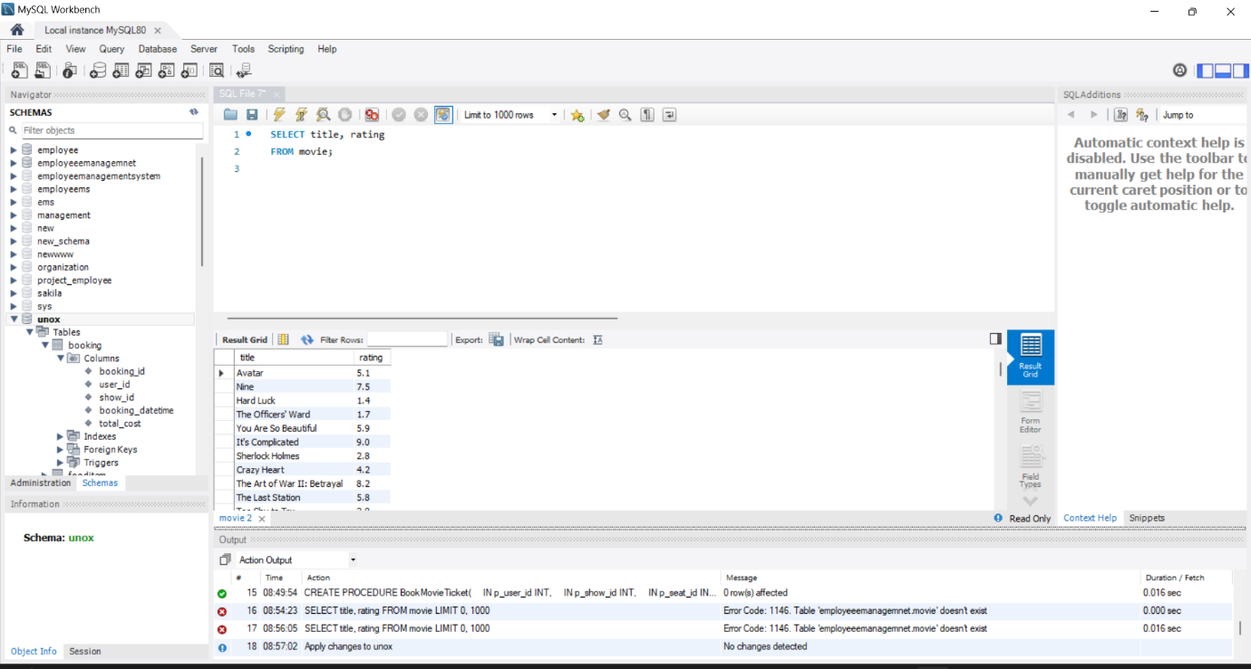1. Retrieve All Movie Titles and Their Ratings

1. List All Users with Their Email Addresses

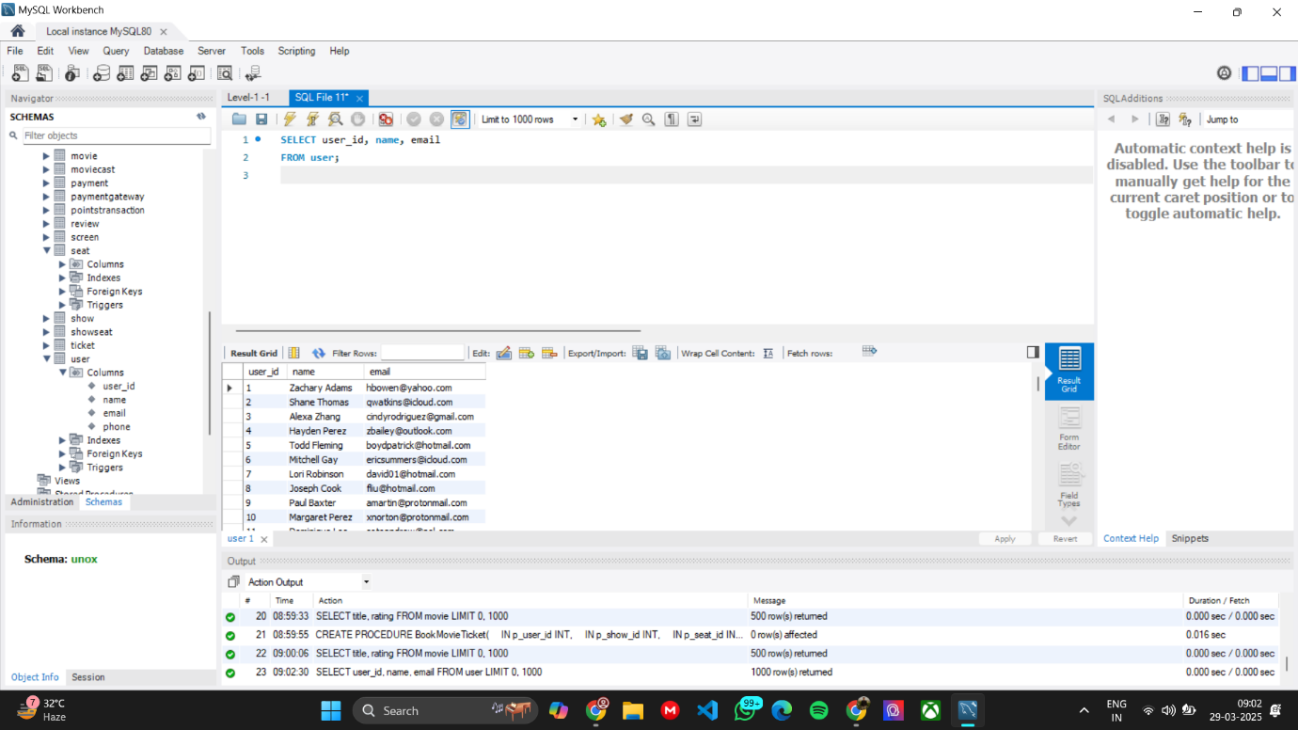

1. 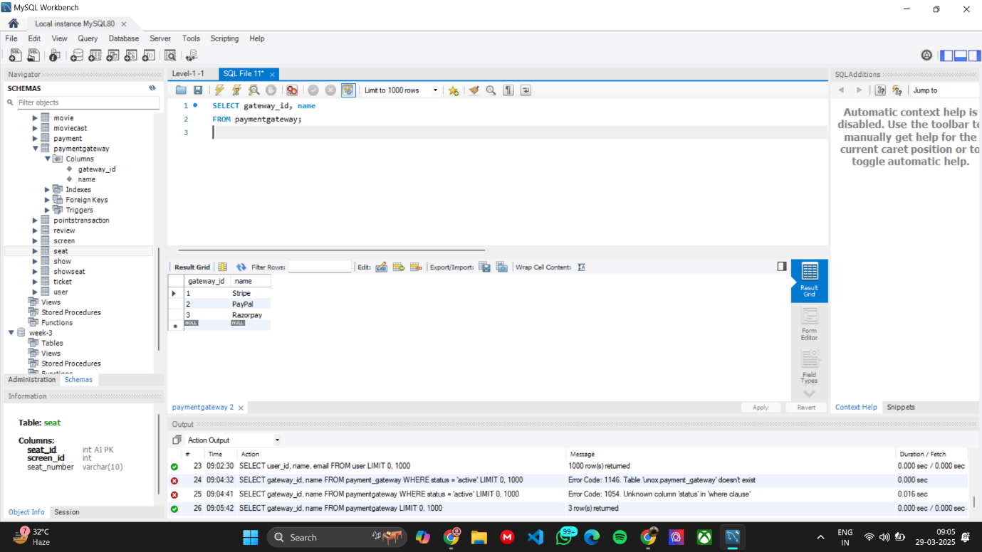List All Available Payment Gateways
2. 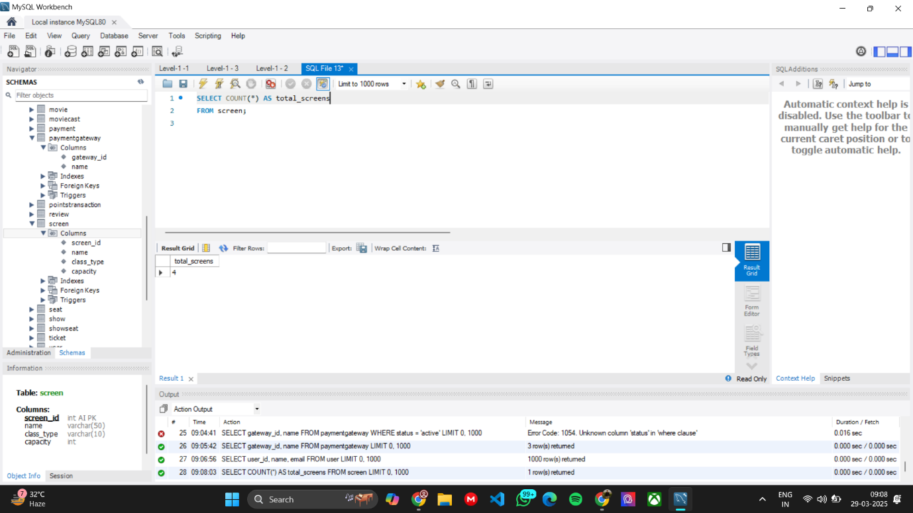Count the Number of Screens in the Theater
3. Find the Names of Movies with a Rating Higher Than 8.0

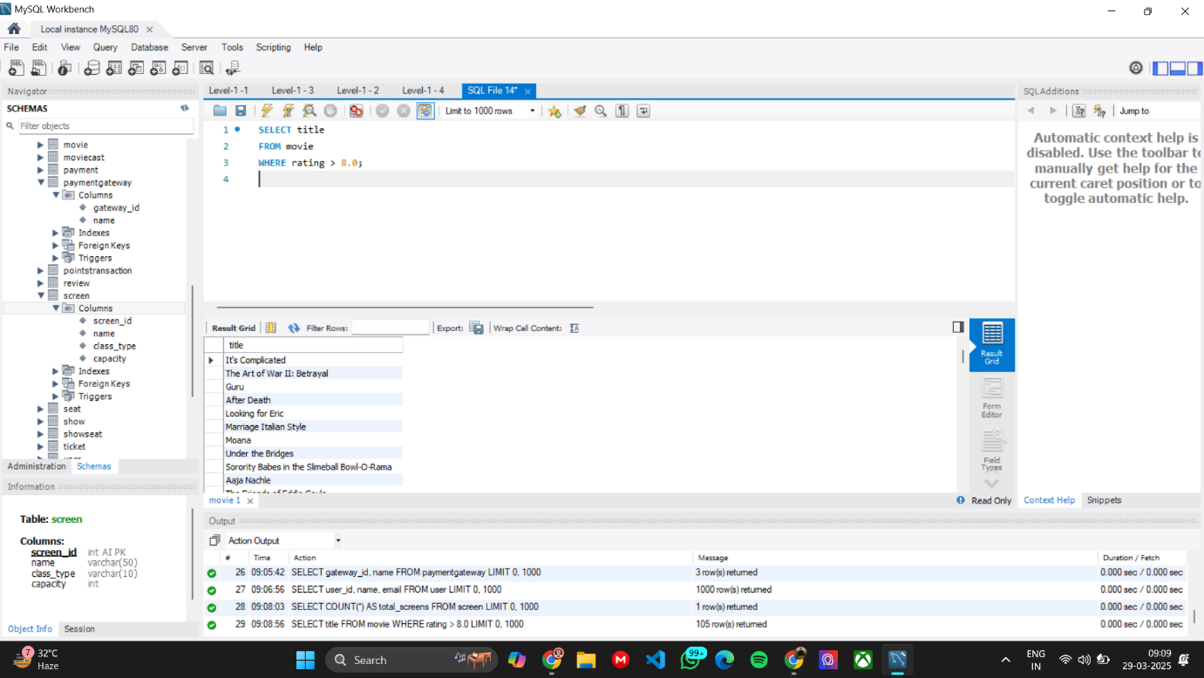

1. Retrieve All Seats for a Given Show ID

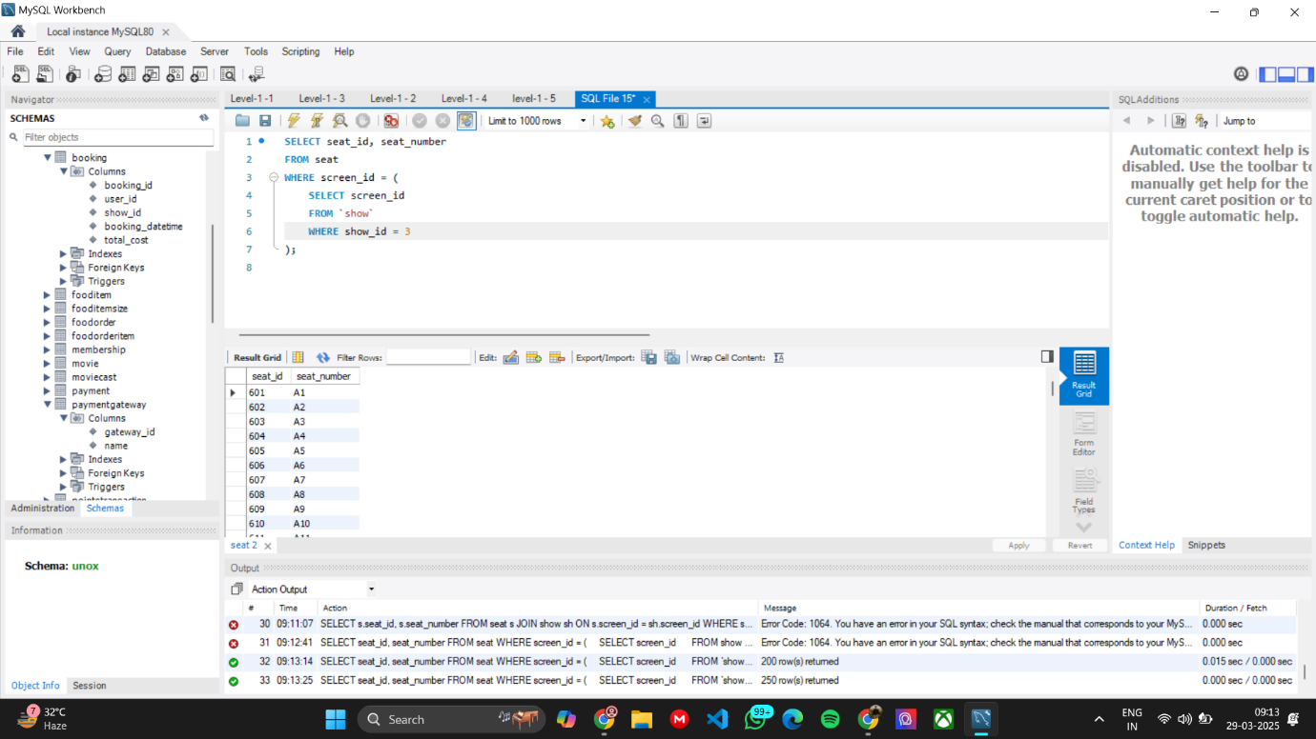

1. Retrieve All Show Dates for a Given Movie

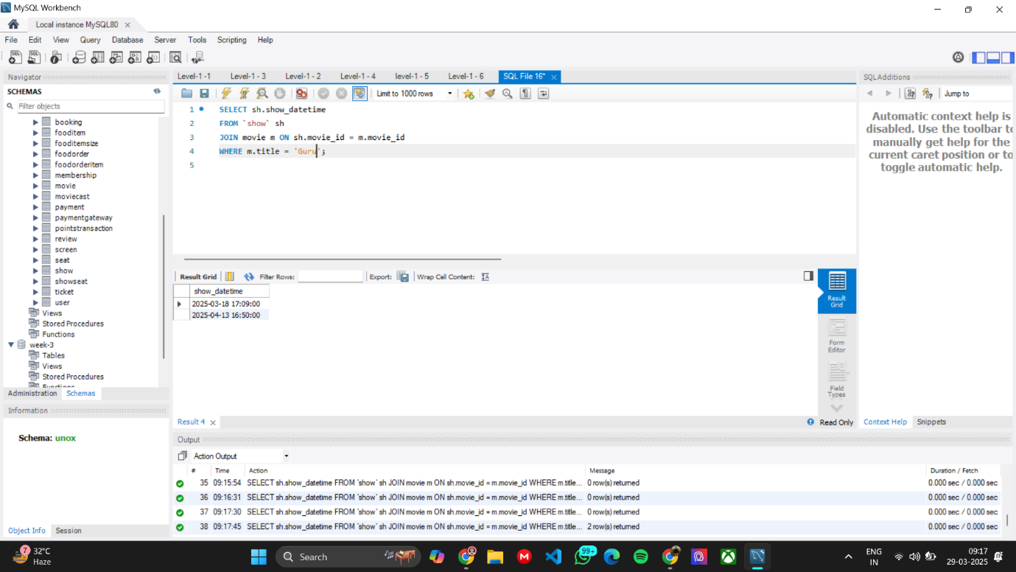

Level 1 - Medium (7 Queries)

1. Get the Total Number of Seats in a Specific Screen

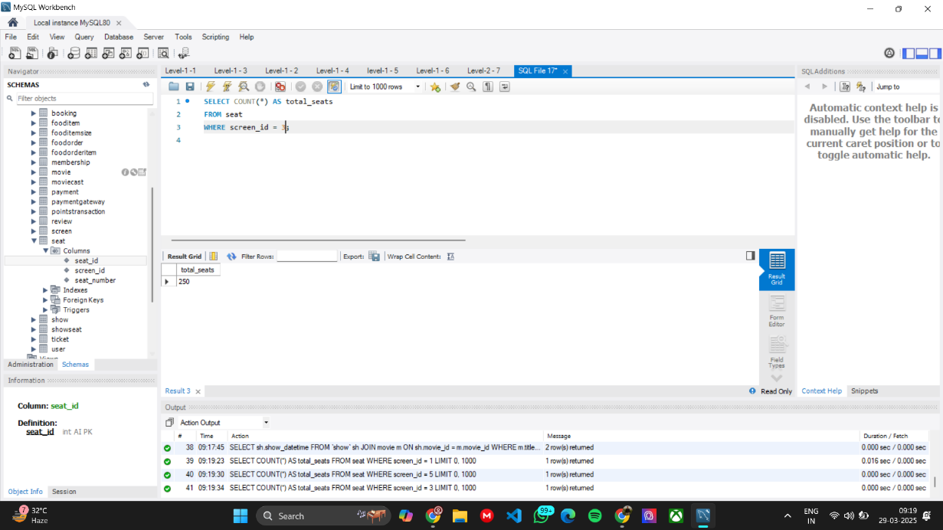

1. List All Movies Along with Their Genres

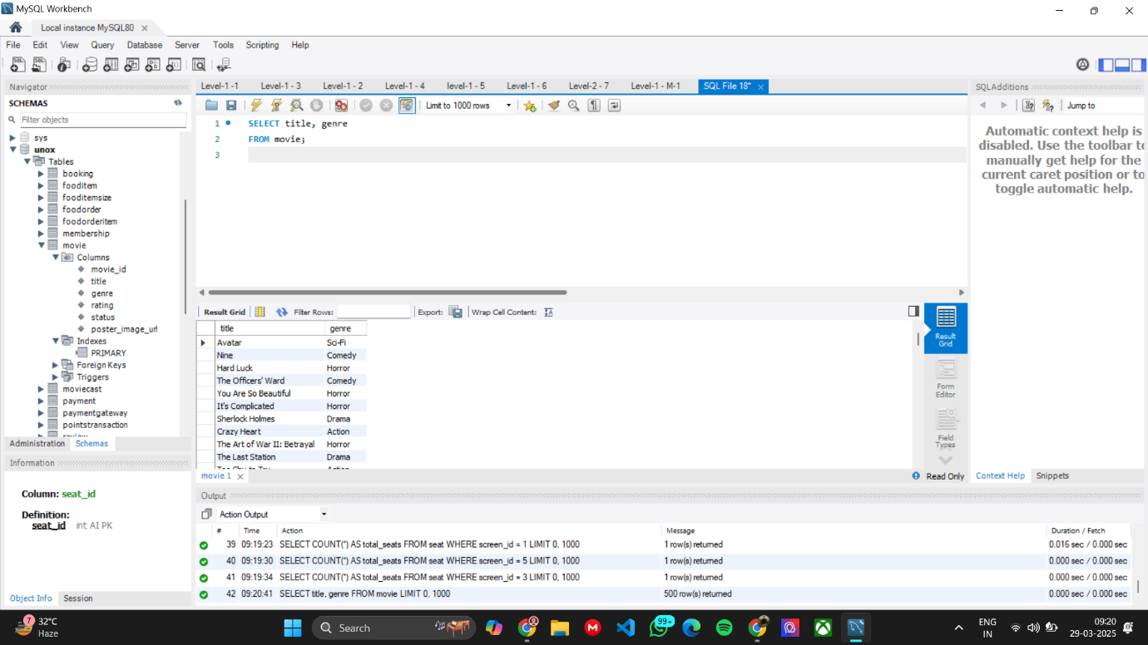

1. Retrieve All Movie Cast Members for a Given Movie

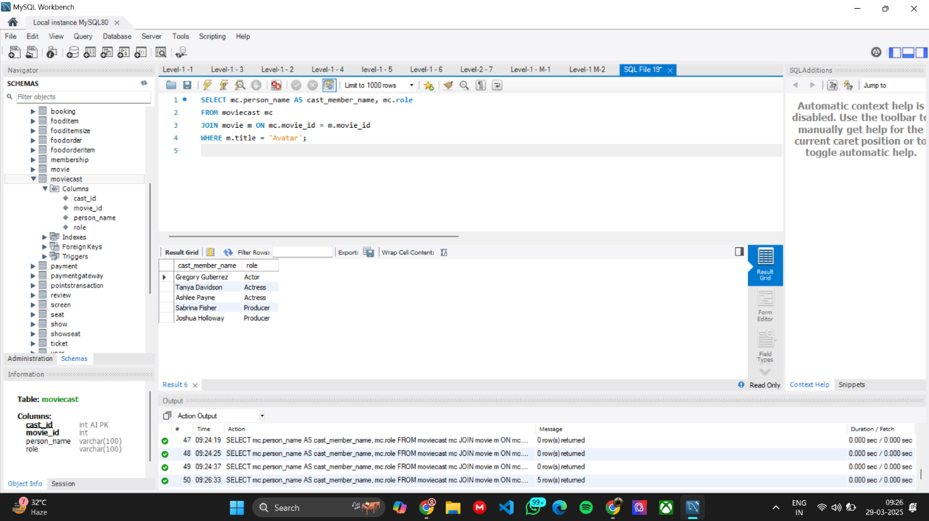

1. List All Screens and Their Capacities

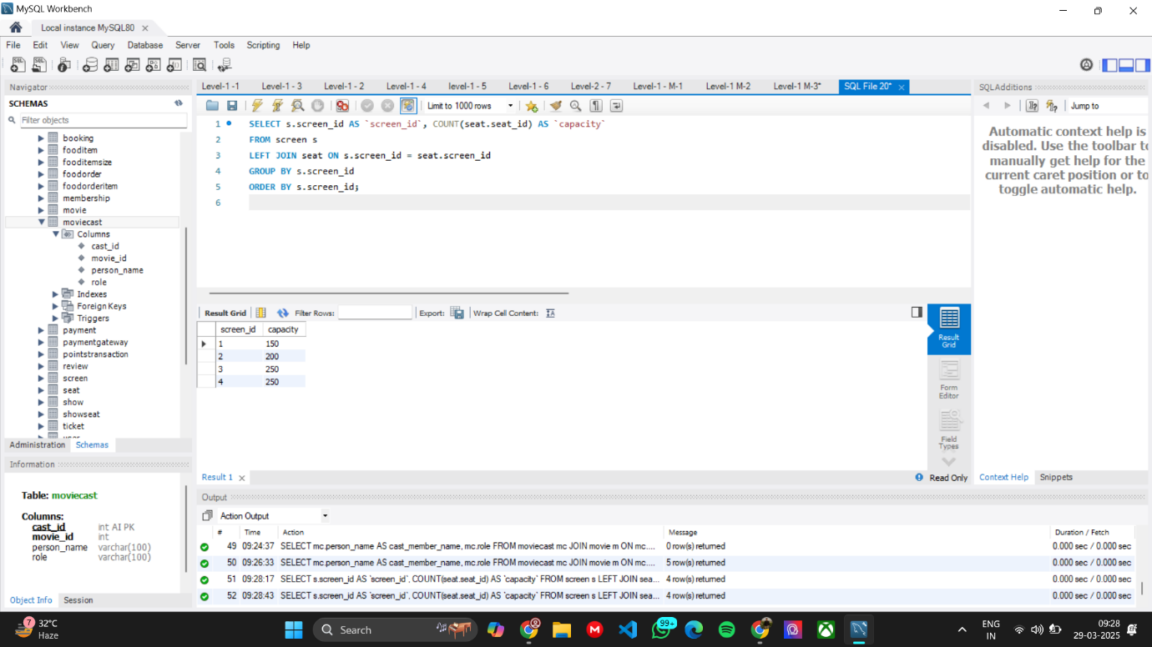

1. Fetch the Total Number of Bookings for a Specific User

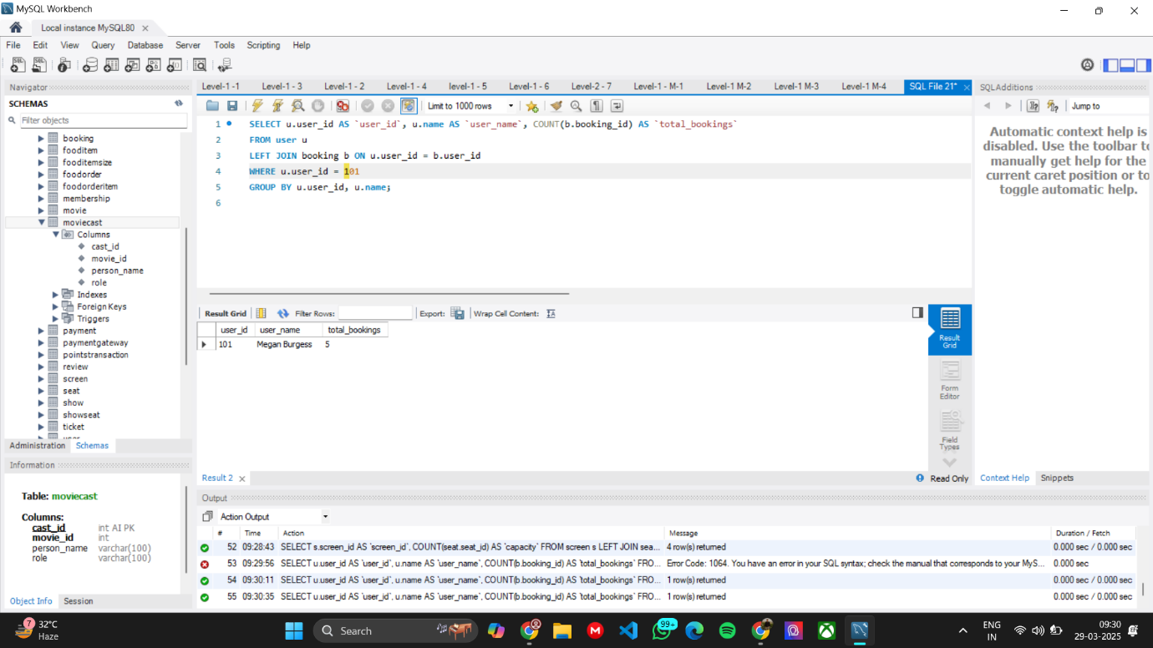

1. Retrieve All Food Orders Placed for a Specific Booking

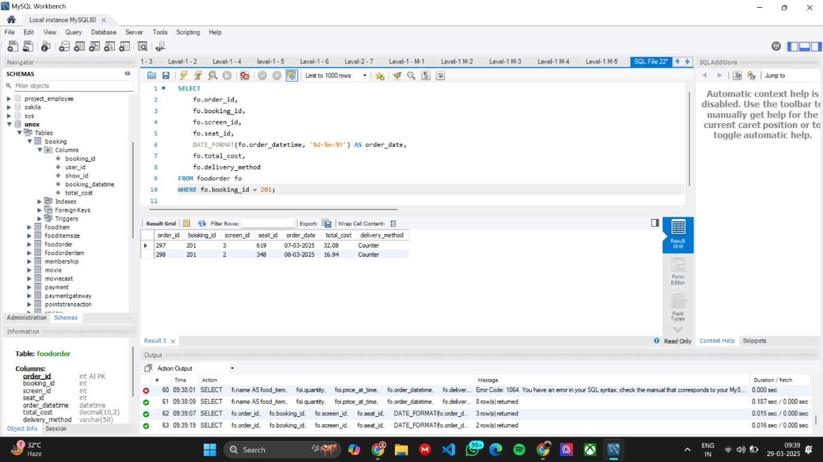

1. Find the Total Number of Food Items Ordered in a Given Order

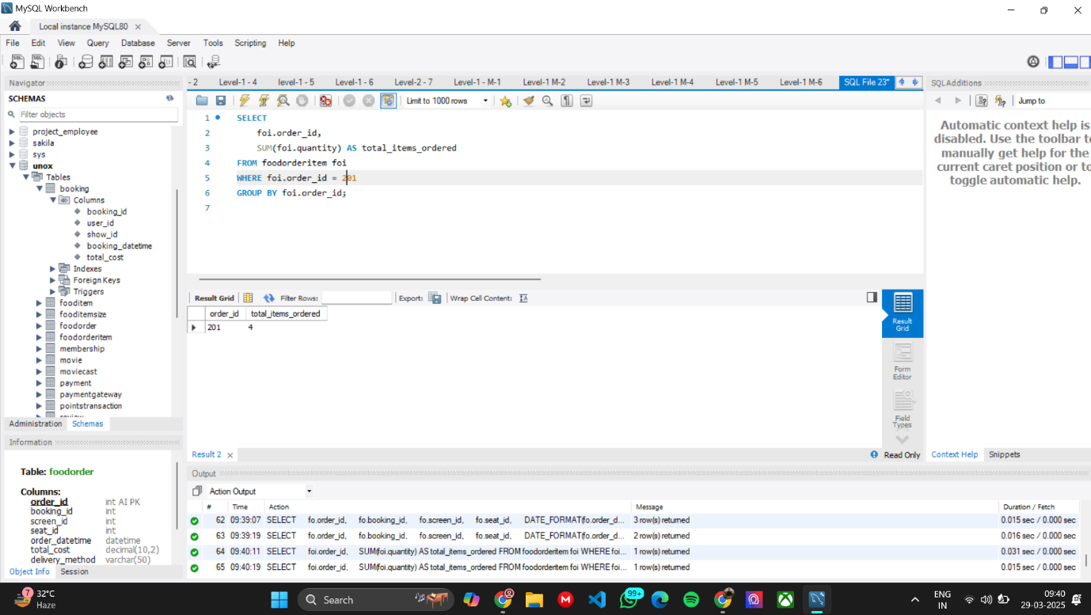

Level 1 - Complex (1 Queries)

1. Calculate the Total Loyalty Points Earned by a Given User

